1. 
2. 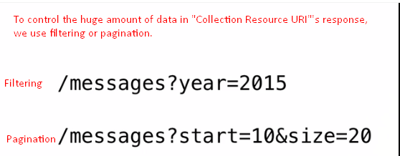
3. 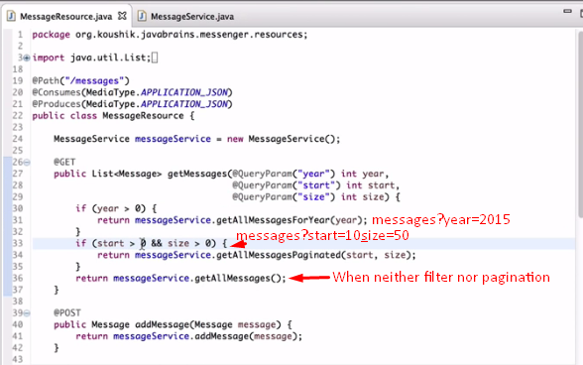  
   When no query parameter is passed, year, start, size have zero value.